CSA0604 – DESIGN AND ANALYSIS OF ALGORITHM
LAB PROGRAMS
SESSION 3
NAME: ABZAM.A
REG NO : 192573029

4. Out of Boundary Paths
Code
#include <stdio.h>
#define MOD 1000000007
int main() {
int m, n, N, i, j;
scanf("%d %d %d %d %d", &m, &n, &N, &i, &j);
long long dp[m][n], next[m][n];
long long answer = 0;
for (int r = 0; r < m; r++)
for (int c = 0; c < n; c++)
dp[r][c] = 0;
dp[i][j] = 1;
for (int step = 1; step <= N; step++) {
for (int r = 0; r < m; r++)
for (int c = 0; c < n; c++)
next[r][c] = 0;
for (int r = 0; r < m; r++) {
for (int c = 0; c < n; c++) {
if (dp[r][c] == 0)
continue;
long long ways = dp[r][c];
if (r == 0) answer = (answer + ways) % MOD;
else next[r - 1][c] = (next[r - 1][c] + ways) % MOD;
if (r == m - 1) answer = (answer + ways) % MOD;
else next[r + 1][c] = (next[r + 1][c] + ways) % MOD;
if (c == 0) answer = (answer + ways) % MOD;
else next[r][c - 1] = (next[r][c - 1] + ways) % MOD;
if (c == n - 1) answer = (answer + ways) % MOD;
else next[r][c + 1] = (next[r][c + 1] + ways) % MOD;
}
}
for (int r = 0; r < m; r++)
for (int c = 0; c < n; c++)
dp[r][c] = next[r][c];
}
printf("Number of paths: %lld\n", answer);
return 0;
}
Time Complexity: O(N × m × n) Space Complexity: O(m × n)

Outputs
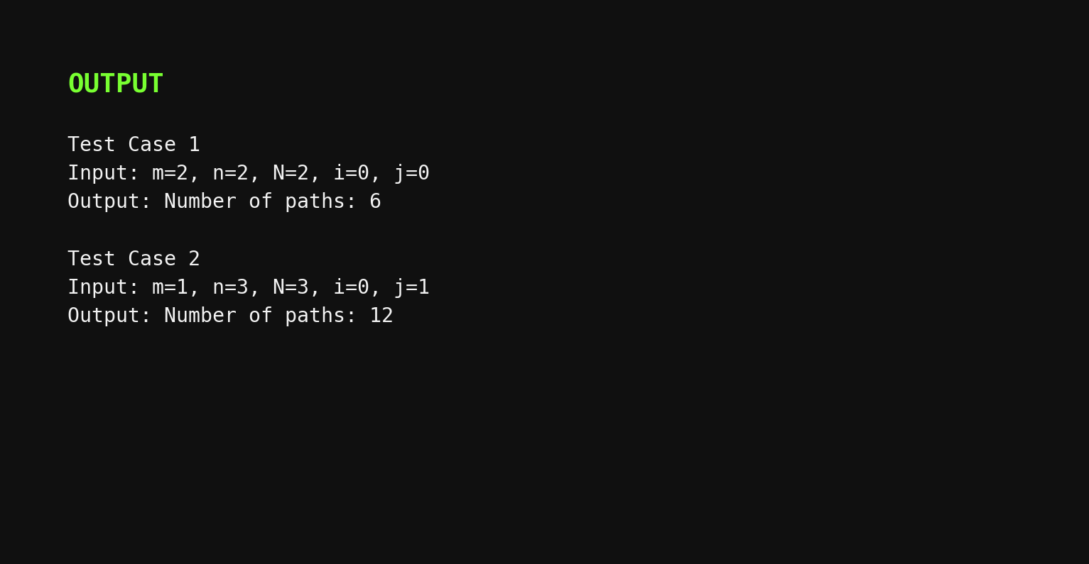

5. House Robber in a Circular Street
Code
#include <stdio.h>
int max(int a, int b) {
return (a > b) ? a : b;
}
int robLinear(int nums[], int start, int end) {
int prev2 = 0;
int prev1 = 0;
for (int i = start; i <= end; i++) {
int current = max(prev1, prev2 + nums[i]);
prev2 = prev1;
prev1 = current;
}
return prev1;
}
int main() {
int n;
scanf("%d", &n);
int nums[n];
for (int i = 0; i < n; i++)
scanf("%d", &nums[i]);
if (n == 1) {
printf("Maximum money: %d\n", nums[0]);
} else {
int withoutLast = robLinear(nums, 0, n - 2);
int withoutFirst = robLinear(nums, 1, n - 1);
printf("Maximum money: %d\n", max(withoutLast, withoutFirst));
}
return 0;
}
Time Complexity: O(n) Space Complexity: O(1)

Outputs
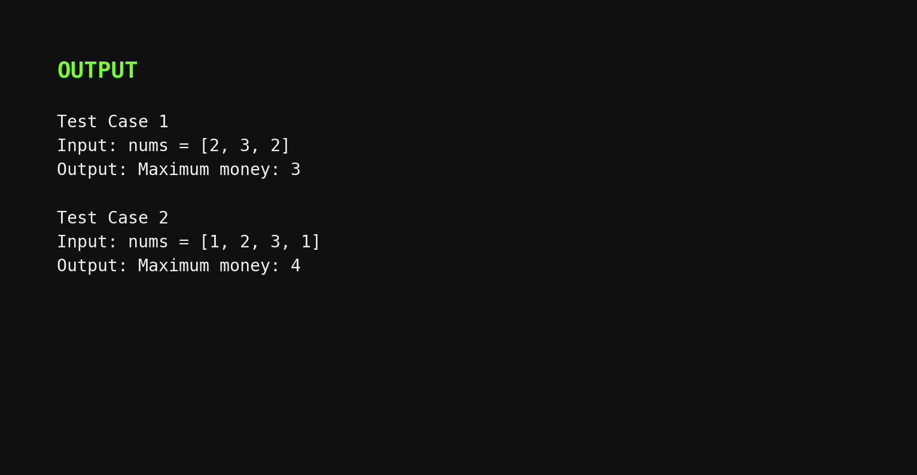

6. Climbing Stairs
Code
#include <stdio.h>
int main() {
int n;
scanf("%d", &n);
if (n <= 2) {
printf("Number of ways: %d\n", n);
return 0;
}
long long oneStepBefore = 2;
long long twoStepsBefore = 1;
long long ways = 0;
for (int i = 3; i <= n; i++) {
ways = oneStepBefore + twoStepsBefore;
twoStepsBefore = oneStepBefore;
oneStepBefore = ways;
}
printf("Number of ways: %lld\n", ways);
return 0;
}
Time Complexity: O(n) Space Complexity: O(1)

Outputs
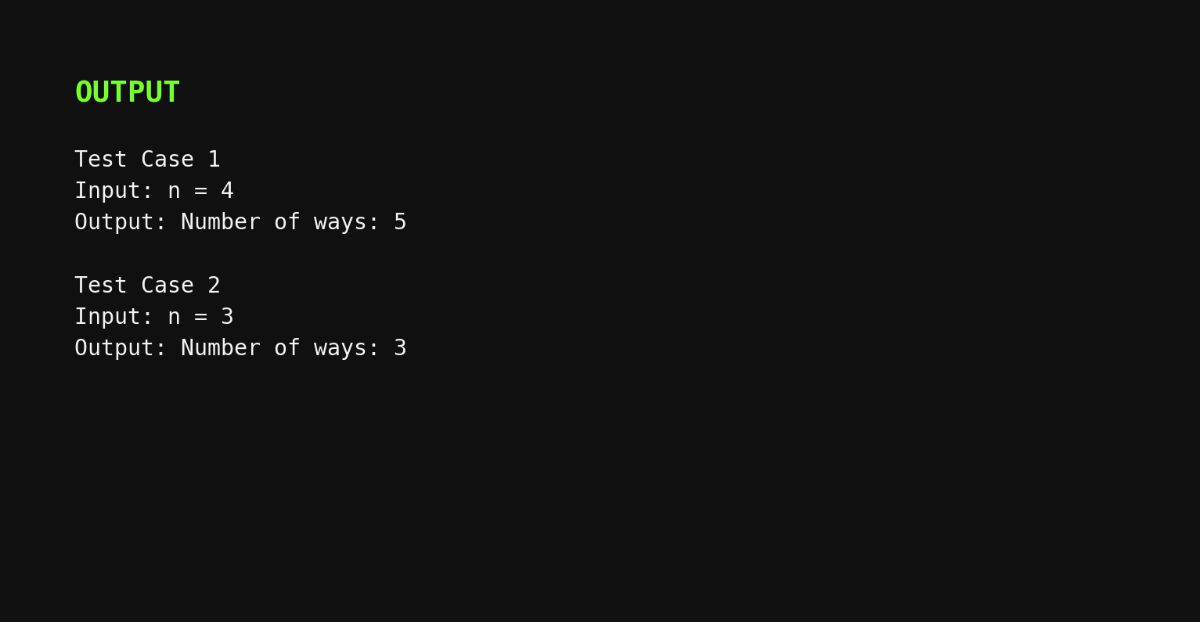

7. Unique Paths in a Grid
Code
#include <stdio.h>
int main() {
int m, n;
scanf("%d %d", &m, &n);
long long dp[n];
for (int j = 0; j < n; j++)
dp[j] = 1;
for (int i = 1; i < m; i++) {
for (int j = 1; j < n; j++) {
dp[j] = dp[j] + dp[j - 1];
}
}
printf("Number of unique paths: %lld\n", dp[n - 1]);
return 0;
}
Time Complexity: O(m × n) Space Complexity: O(n)

Outputs
